PROFESSIONAL ELECTIVE-I
APPLIED DATA SCIENCE
PROTOTYPE REPORT

ON

SUPPLYCHAIN NEXUS
Disruption Propagation & Recovery Planning

Submitted to JNTUH In the partial fulfillment of the Academic Requirements for the award of the degree of
BACHELOR’S OF TECHNOLOGY
in
COMPUTER SCIENCE AND ENGINEERING – AIML
BY

R. Jashwanth (24QM1A66A2)
Rahul Burdak (24QM1A66A1)
C.Bharath (25QM5A6605)

Under the Guidance of Internal Expert
Mr. M Vishnu Vardhan
ASSISTANT PROFESSOR
Computer Science and Engineering - AIML


DEPARTMENT OF COMPUTER SCIENCE AND ENGINEERING - AIML
KG REDDY COLLEGE OF ENGINEERING AND TECHNOLOGY
(Approved by AICTE, New Delhi, Affiliated to JNTUH,Hyderabad.)
Chilkur (V), Moinabad Mandal, R. R. Dist – 501 504, Ph: 9247033008, 9000633008
Website: WWW. Kgr.ac.in
Batch: 2024- 2028

CHAPTER 1

PROBLEM FORMULATION

  - INTRODUCTION

Modern supply chains consist of multiple interconnected entities such as SUPPLIERS, TRANSPORTATION NETWORKS, PORTS, MANUFACTURING FACILITIES, WAREHOUSES, DISTRIBUTORS, RETAILERS AND CUSTOMERS. A product may pass through several of these stages before reaching the final customer. Because these entities are highly dependent on one another, a disruption at one point can create a CHAIN REACTION across other parts of the supply chain.

Disruptions may occur due to SUPPLIER FAILURE, PORT CLOSURES, TRANSPORTATION INTERRUPTIONS, EXTREME WEATHER, GEOPOLITICAL EVENTS, STRIKES, CONGESTION OR INFRASTRUCTURE FAILURES. For example, if a critical supplier stops providing raw materials, the manufacturing facility depending on that supplier may experience production delays. Similarly, if a major port becomes unavailable, shipments may be delayed, affecting factories, warehouses and ultimately customers.

The major challenge is not only to identify that a disruption has occurred, but also to understand WHAT WILL BE AFFECTED, HOW SERIOUS THE IMPACT WILL BE, AND WHAT ACTION SHOULD BE TAKEN. A decision made without understanding the complete dependency structure can result in unnecessary cost, longer delays or additional risk.

SupplyChain Nexus is proposed as a DATA-DRIVEN SUPPLY-CHAIN DECISION-SUPPORT SYSTEM that combines data analysis, statistical techniques, machine learning and graph-based network analysis. The proposed system will trace the possible propagation of a disruption through connected supply-chain entities, estimate its potential operational impact and compare alternative recovery strategies.

The system is therefore designed around the workflow:
DISRUPTION → PROPAGATION → IMPACT → RECOVERY → DECISION

The final objective is to help decision makers move from simply knowing that a disruption exists to understanding WHAT IT COULD AFFECT AND WHAT CAN BE DONE ABOUT IT.

  - PROBLEM STATEMENT

Supply chains consist of interconnected suppliers, transportation routes, ports, factories, warehouses and distribution channels. A disruption at any important point can affect several connected operations, leading to DELAYS, SHORTAGES, INCREASED COSTS AND CUSTOMER IMPACT.

The main problem is that identifying a disruption alone is not sufficient. Organizations also need to understand WHICH PARTS OF THE SUPPLY CHAIN WILL BE AFFECTED, HOW SERIOUS THE IMPACT MAY BE, AND WHAT RECOVERY OPTIONS ARE AVAILABLE.

Therefore, SupplyChain Nexus proposes a data-driven system that analyses supply-chain dependencies, estimates disruption impact and compares alternative recovery strategies using DATA ANALYSIS, MACHINE LEARNING AND NETWORK ANALYSIS.

  - SCOPE

The scope of SupplyChain Nexus includes:

- Collection and integration of SUPPLY-CHAIN, TRANSPORTATION AND DISRUPTION DATA.
- Data cleaning, preprocessing and exploratory analysis using Python.
- Statistical analysis to identify important patterns and relationships.
- Application of MACHINE LEARNING for suitable risk or delay prediction tasks.
- NETWORK ANALYSIS to identify dependencies and trace disruption propagation.
- Estimation of potential impact on connected supply-chain entities.
- Comparison of recovery options such as ALTERNATIVE SUPPLIERS, ROUTES, PORTS AND TRANSPORTATION MODES.
- Visualization of analytical results using POWER BI.
- Development of an interactive STREAMLIT application in the final implementation.

  - OBJECTIVES

- To collect and integrate relevant SUPPLY-CHAIN AND DISRUPTION DATA.
- To perform data preprocessing, exploratory analysis and STATISTICAL ANALYSIS.
- To identify important factors associated with supply-chain disruptions and delays.
- To develop suitable MACHINE LEARNING MODELS for risk or impact prediction.
- To analyse supply-chain dependencies using GRAPH-BASED NETWORK ANALYSIS.
- To identify the potential DOWNSTREAM IMPACT of a disruption.
- To compare alternative recovery strategies based on RISK, DELAY AND COST.
- To provide an INTERACTIVE DATA-DRIVEN DECISION-SUPPORT SYSTEM.

  - EXISTING SYSTEM

Existing supply-chain systems provide capabilities such as SUPPLIER RISK MONITORING, SHIPMENT TRACKING, DELAY PREDICTION, ROUTE OPTIMIZATION AND LOGISTICS ANALYTICS.

Some systems use machine learning to predict delays or identify risks, while others focus on transportation optimization and supply-chain visibility. Network-based approaches are also used to study relationships between supply-chain entities.

However, these capabilities are often handled as SEPARATE ANALYTICAL FUNCTIONS. A disruption may be detected by one system, while its downstream impact and recovery options may require analysis using other tools.

  - DISADVANTAGES OF EXISTING SYSTEM

- SEPARATED ANALYSIS: Risk, prediction, monitoring and optimization may be handled independently.
- LIMITED IMPACT VISIBILITY: The complete downstream effect of a disruption may not be clearly identified.
- WEAK DEPENDENCY VISIBILITY: Complex relationships between suppliers, routes, facilities and products can be difficult to analyse using only traditional tables.
- PREDICTION WITHOUT ACTION: A system may predict a risk or delay without suggesting suitable recovery options.
- SINGLE-FACTOR DECISIONS: Some approaches focus mainly on cost, distance or time instead of considering RISK, COST AND DELAY TOGETHER.
- CASCADING DISRUPTIONS: The chain reaction caused by one disrupted node may not be fully analysed.
- DATA LIMITATIONS: Complete supply-chain relationships are often proprietary, making comprehensive analysis difficult with public datasets.

SupplyChain Nexus aims to connect these stages into one workflow:
DISRUPTION → IMPACT → RECOVERY OPTIONS → DECISION

CHAPTER 2

LITERATURE SURVEY

Supply-chain disruptions have been widely studied from the perspectives of SUPPLY-CHAIN RISK, RESILIENCE, DISRUPTION SEVERITY, NETWORK DEPENDENCIES, MACHINE LEARNING AND DECISION SUPPORT. The literature shows that supply chains behave as interconnected networks, where disruption at a critical node can affect other dependent entities. Research has also increasingly explored data-driven and AI-based methods for early disruption detection, stress testing and recovery planning.

Craighead et al. studied the severity of supply-chain disruptions and showed that factors such as SUPPLY-CHAIN DENSITY, COMPLEXITY AND NODE CRITICALITY influence disruption severity. The study also highlighted the importance of warning and recovery capabilities in reducing disruption consequences.

Ivanov and Dolgui proposed the concept of a DIGITAL SUPPLY CHAIN TWIN for disruption-risk management and resilience. Their work combines model-based and data-driven approaches to represent supply-chain states, analyse disruption information and support predictive and reactive decisions.

Ivanov later proposed an INTELLIGENT DIGITAL TWIN framework for supply-chain stress testing, resilience and viability. The framework integrates analytics, disruption prediction, event-driven responses and decision-support capabilities, providing a foundation for proactive supply-chain resilience.

Recent research has increasingly applied MACHINE LEARNING AND GRAPH-BASED METHODS to supply-chain disruption prediction. A 2026 study proposed a graph neural network and ensemble-learning framework to identify direct and indirect disruption-risk propagation paths, demonstrating the growing importance of combining network structure with predictive modelling.

Research has also investigated machine learning for predicting product availability under disruption. Camur, Ravi and Saleh evaluated regression models for predicting product availability dates and found Random Forest and Gradient Boosting approaches effective for their studied application.

These studies provide the foundation for SupplyChain Nexus. The proposed project draws from these areas and combines DATA ANALYSIS, MACHINE LEARNING, NETWORK-BASED DISRUPTION PROPAGATION AND RECOVERY DECISION SUPPORT into a single academic prototype.

LITERATURE SURVEY TABLE

S.No. | Authors & Year | Study | Method / Focus | Key Finding | Relevance
1 | Craighead et al. (2007) | Severity of Supply Chain Disruptions | Disruption severity & mitigation | Node criticality and supply-chain complexity affect disruption severity. | Critical-node analysis
2 | Ivanov & Dolgui (2021) | Digital Supply Chain Twin | Digital twin & resilience | Supports disruption-risk management and supply-chain visibility. | Digital supply-chain modelling
3 | Ivanov (2023) | Intelligent Digital Twin | AI & decision support | Combines prediction, monitoring and response for resilience. | Prediction + decision support
4 | Camur et al. (2024) | Product Availability Under Disruption | Machine Learning | ML can predict product availability under disruption. | Delay / impact prediction
5 | Khaled et al. (2024) | Early Supply-Chain Disruption Prediction | Machine Learning | ML approaches can support early disruption prediction. | Risk prediction
6 | Zhao et al. (2026) | Logistics Disruption Prediction | Graph + ML | Combines graph-based risk inference with forecasting. | Propagation + prediction
7 | Wang et al. (2026) | Early Warning Under Uncertainty | Interpretable ML | Uses interpretable ML for disruption early warning. | Explainable prediction

CHAPTER 3

DATASET COLLECTION

The dataset for this study will be collected from PUBLICLY AVAILABLE SUPPLY-CHAIN, TRADE, TRANSPORTATION AND DISRUPTION DATA SOURCES. Since a complete commercial supply chain is generally not available as a single public dataset, multiple datasets will be integrated to represent important supply-chain relationships, disruptions and operational factors.
Supply-Chain and Trade Features:
- Supplier / Origin, Destination, Product and Trade Volume: These features represent the movement and dependency of goods between different locations and supply-chain entities.
Transportation Features:
- Transportation Mode, Route, Distance, Shipment and Delivery Time: These features support analysis of transportation performance, delays and alternative movement options.
Disruption Features:
- Disruption Type, Location, Date, Duration and Severity: These features capture events that may affect suppliers, transportation networks, ports or other supply-chain nodes.
Operational Features:
- Facility, Warehouse, Capacity, Inventory and Lead Time: These features support downstream impact analysis and evaluation of possible recovery strategies where available.
External Factors:
- Weather, Geopolitical Events and Other Relevant External Indicators: These features can be used to identify external factors associated with supply-chain disruptions.
Dataset Size:
The final dataset size will depend on the AVAILABILITY, QUALITY AND COMPATIBILITY OF THE SELECTED PUBLIC DATA SOURCES. Multiple datasets will be cleaned, standardized and integrated before analysis. Where complete supply-chain relationships are unavailable, clearly labelled SYNTHETIC SCENARIO DATA may be created for controlled disruption and recovery experiments.
Utility:
The collected dataset will provide the foundation for EXPLORATORY DATA ANALYSIS, STATISTICAL ANALYSIS, MACHINE LEARNING AND NETWORK-BASED SUPPLY-CHAIN ANALYSIS. It will support identification of disruption patterns, prediction of suitable risk or delay measures, analysis of affected supply-chain entities and comparison of alternative recovery strategies.
DATASET:
To be finalized after verification and integration of the selected public datasets.

CHAPTER 4

SOFTWARE DESIGN

The proposed SupplyChain Nexus platform is designed as a data-driven decision-support system for analysing supply-chain disruptions and their downstream effects. The system integrates DATA INGESTION, DATA PROCESSING, STATISTICAL ANALYSIS, MACHINE LEARNING AND GRAPH-BASED NETWORK ANALYSIS to identify vulnerable supply-chain entities and estimate potential disruption impact.

Supply-chain data from multiple sources will be cleaned, transformed and stored in a structured MySQL DATABASE. Python-based analytical modules will perform exploratory analysis, statistical analysis and machine-learning-based risk or delay prediction where suitable data is available. A NETWORK ANALYSIS LAYER will represent relationships between suppliers, transportation nodes, ports, facilities and other entities to trace possible disruption propagation.

The proposed IMPACT AND RECOVERY ENGINE will analyse affected entities and compare possible recovery strategies such as alternative suppliers, routes, ports or transportation modes using factors such as RISK, DELAY, COST AND CAPACITY, wherever the required data is available. Analytical results will be presented through POWER BI, while a STREAMLIT APPLICATION will provide interactive disruption scenarios and decision-support functionality.

4.1 SYSTEM ARCHITECTURE

The proposed architecture consists of separate layers for DATA COLLECTION, STORAGE, PROCESSING, ANALYTICS, MACHINE LEARNING, NETWORK ANALYSIS AND DECISION SUPPORT. Multiple supply-chain datasets will be collected and integrated before being stored in MySQL.
The Python processing layer will perform data cleaning, transformation and feature engineering. The analytical layer will perform EDA and statistical analysis, while the machine-learning layer will generate suitable risk or delay predictions. The NETWORK ANALYSIS LAYER will model supply-chain dependencies and identify entities potentially affected by a disruption.
The IMPACT ENGINE will estimate downstream exposure, and the RECOVERY ENGINE will compare available alternatives. Power BI will provide analytical dashboards, while Streamlit will provide an interactive interface for scenario-based analysis.
Proposed Architecture:
DATA SOURCES → DATA PROCESSING → MYSQL DATABASE → EDA & STATISTICS → ML ENGINE → NETWORK ANALYSIS → IMPACT ENGINE → RECOVERY ENGINE → POWER BI / STREAMLIT
FIG 1: SYSTEM ARCHITECTURE

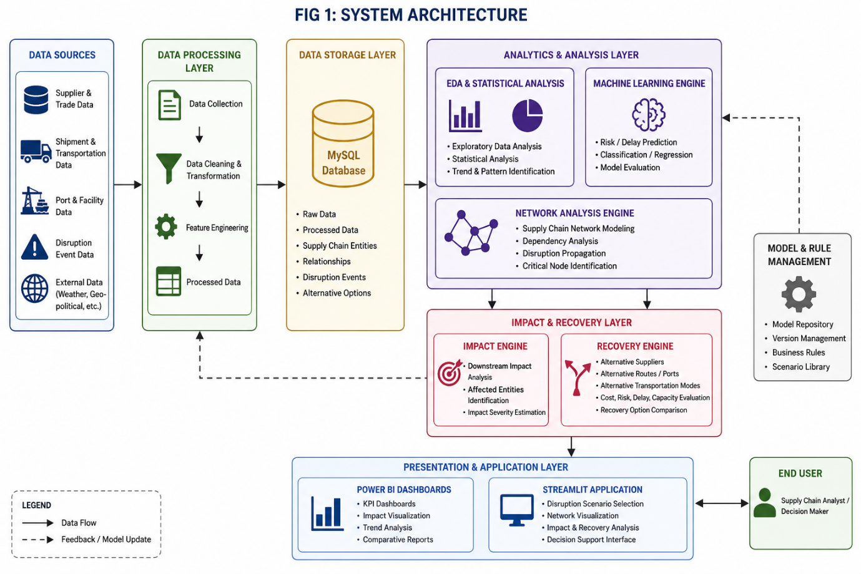

4.2 DATA FLOW DIAGRAM

The Data Flow Diagram represents the movement of information from external supply-chain data sources through the analytical system. Data related to SUPPLIERS, SHIPMENTS, TRANSPORTATION, PORTS, FACILITIES AND DISRUPTION EVENTS is collected and passed to the preprocessing layer.
The cleaned data is stored in the database and used for exploratory and statistical analysis. Relevant features are then provided to the machine-learning and network-analysis modules. When a disruption scenario is selected, the system identifies connected entities, estimates the potential impact and evaluates available recovery alternatives.
The final analytical results are provided to users through POWER BI DASHBOARDS AND THE STREAMLIT APPLICATION.
Data Sources → Data Collection → Data Cleaning → MySQL → Analytics / ML → Network Analysis → Impact & Recovery → User
FIG 2: DATA FLOW DIAGRAM

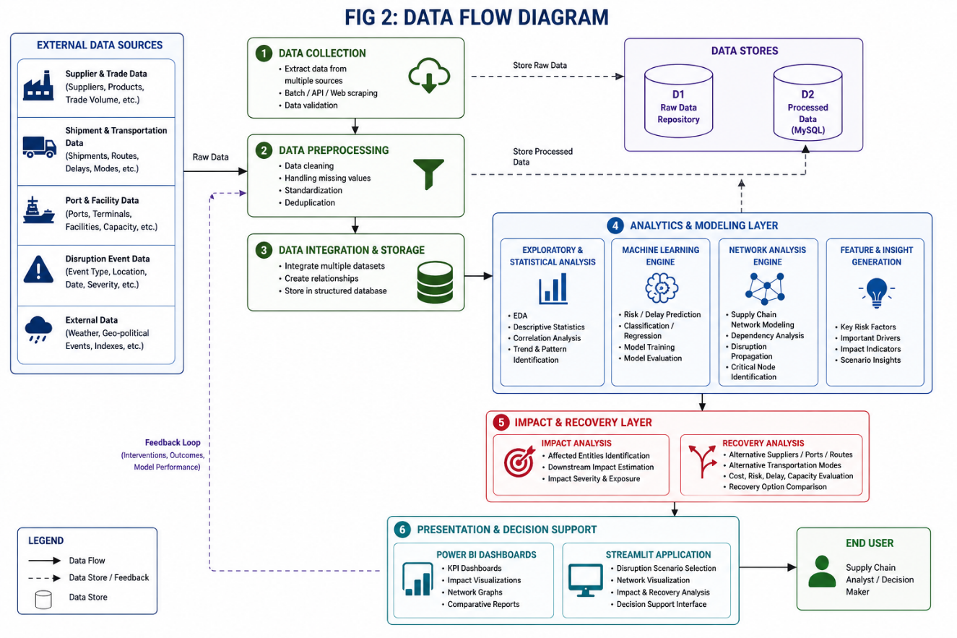

4.3 USE CASE DIAGRAM

The primary actor of the proposed system is the SUPPLY CHAIN ANALYST / DECISION MAKER.
The user can interact with the system to:
- View supply-chain information
- Analyse disruption risks
- Select a disruption scenario
- Identify affected supply-chain entities
- View disruption propagation
- Analyse predicted impact
- View important risk factors
- Compare recovery alternatives
- View the recommended recovery strategy
- Explore analytical results through dashboards

The use-case design focuses on providing the user with a COMPLETE DECISION VIEW rather than only displaying a prediction or disruption alert.
FIG 3: USE CASE DIAGRAM

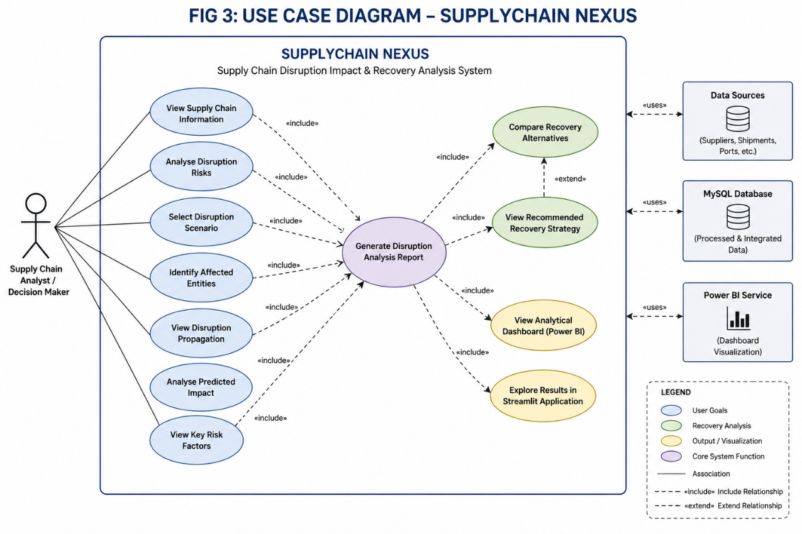

4.4 SEQUENCE DIAGRAM

A typical disruption-analysis sequence begins when the user selects a DISRUPTION SCENARIO, such as supplier failure, port unavailability or transportation disruption.
The application retrieves the required information from the database. The analytical modules evaluate the disruption, while the NETWORK ANALYSIS ENGINE identifies connected and potentially affected entities. The prediction module estimates relevant risk or delay measures, after which the impact engine calculates the potential downstream exposure.
The recovery engine then evaluates available alternatives and compares them using the defined decision criteria. Finally, the system presents the IMPACT ANALYSIS AND RECOVERY RECOMMENDATION to the user.
User → Select Disruption → Database → ML Analysis → Network Analysis → Impact Engine → Recovery Engine → Recommendation → User

FIG 4: SEQUENCE DIAGRAM

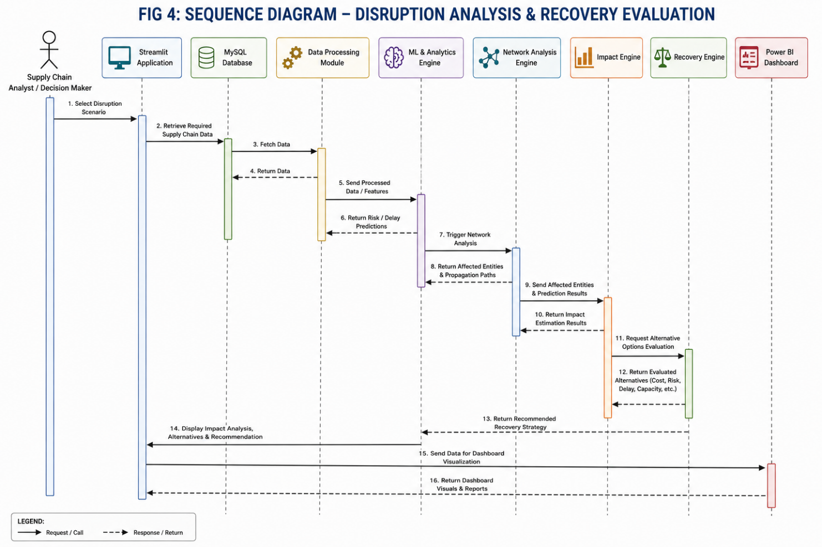

4.5 COMPONENT DIAGRAM
The proposed system consists of modular components with clearly defined responsibilities. The major components include the DATA INGESTION MODULE, DATA PROCESSING MODULE, DATABASE, ANALYTICS ENGINE, MACHINE LEARNING ENGINE, NETWORK ANALYSIS ENGINE, IMPACT ENGINE, RECOVERY ENGINE, POWER BI DASHBOARD AND STREAMLIT APPLICATION.
The Data Ingestion and Processing modules prepare the data for analysis, while MySQL provides structured storage. The Analytics and ML modules perform statistical analysis and prediction. The Network Analysis module represents supply-chain dependencies and traces disruption propagation.
The IMPACT ENGINE AND RECOVERY ENGINE convert analytical results into decision-support information. Power BI and Streamlit provide the final visualization and interaction layers.
This modular architecture improves MAINTAINABILITY, REUSABILITY AND EXTENSIBILITY of the proposed system.

FIG 5: COMPONENT DIAGRAM

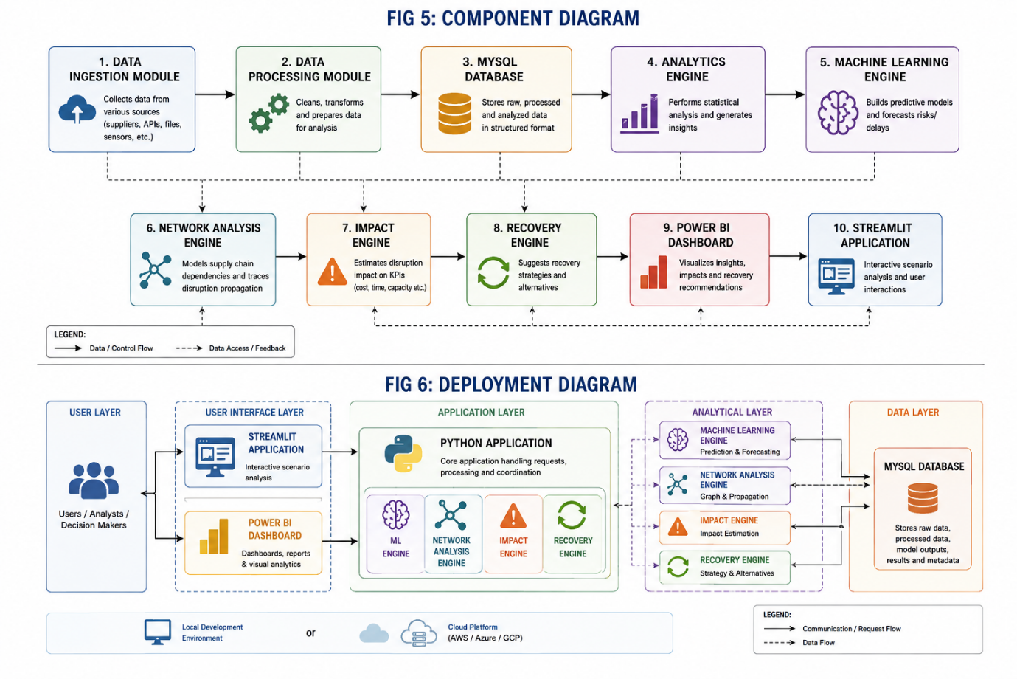
4.6 DEPLOYMENT DIAGRAM

The proposed deployment architecture consists of a user interface layer, application layer, analytical layer and data layer. Users will access the system through the STREAMLIT APPLICATION for interactive scenario analysis and POWER BI for analytical dashboards.
The Python application will communicate with the analytical modules, including the machine-learning, network-analysis, impact and recovery components. The MYSQL DATABASE will store the structured datasets and processed information required by these modules.
For the prototype, the system can initially be deployed on a local development environment and later hosted on a suitable cloud platform if required.
Deployment Flow:
USER → STREAMLIT / POWER BI → PYTHON APPLICATION → ML / NETWORK / IMPACT / RECOVERY MODULES → MYSQL DATABASE
FIG 6: DEPLOYMENT DIAGRAM

CONCLUSION

The proposed SupplyChain Nexus system aims to provide a data-driven approach for analysing supply-chain disruptions and their downstream impact. The project combines DATA ANALYSIS, MACHINE LEARNING AND NETWORK ANALYSIS to identify affected entities and evaluate possible recovery strategies.
The proposed architecture, dataset requirements and system design establish the foundation for the implementation phase. In the next stage, the system will be developed and evaluated using suitable real-world and scenario-based data to provide ACTIONABLE SUPPLY-CHAIN DECISIONS.

THANKYOU

